
Cambridge CELTA Application task
Full name:
Course applied for:  (delete as appropriate) | Part time/Fulltime  January/September/July

Once completed, please upload your task to Learner Gateway along with your application and personal statement
Aims of the task:
- To provide an introduction to the issues studied on the course
- To provide the course tutors with a basis for selecting candidates for interview

Please complete the tasks as well as you can. You may find it useful to refer to a grammar book, e.g., Practical English Usage by Michael Swan (OUP) or An A-Z of English Grammar and Usage by Geoffrey Leach, Benita Cruickshank and Roz Ivanic (Longman).
There are three different tasks to complete
- Language analysis and error correction
- Lesson planning
- Learning English
- Personal statement

Language analysis and error correction
Each of the sentences below contain some sort of error (grammatical, register etc). For each one:
- Identify the error
- Correct the error
- Tell us how you would explain this mistake to help the learner avoid making it again.
I need some informations.

Identify the error
Correct the error
Explanation for the learner

I am learning English every night

Identify the error
Correct the error
Explanation for the learner

A: Have you been to Paris?
B: Yes, I have been last year

Identify the error
Correct the error
Explanation for the learner

In a shop:
A: Morning, what can I get for you?
B: I wonder if you would mind giving me a packet of crisps

Identify the error
Correct the error
Explanation for the learner

I not go shopping every day. I only go on Mondays and Fridays.

Identify the error
Correct the error
Explanation for the learner

Lesson planning
Imagine you are teaching a group of learners at a pre intermediate (A2) level. Look at the materials below, taken from LeBeau, I., & Rees, G. (2008) Language Leader, Pre-Intermediate Coursebook, Harlow: Pearson
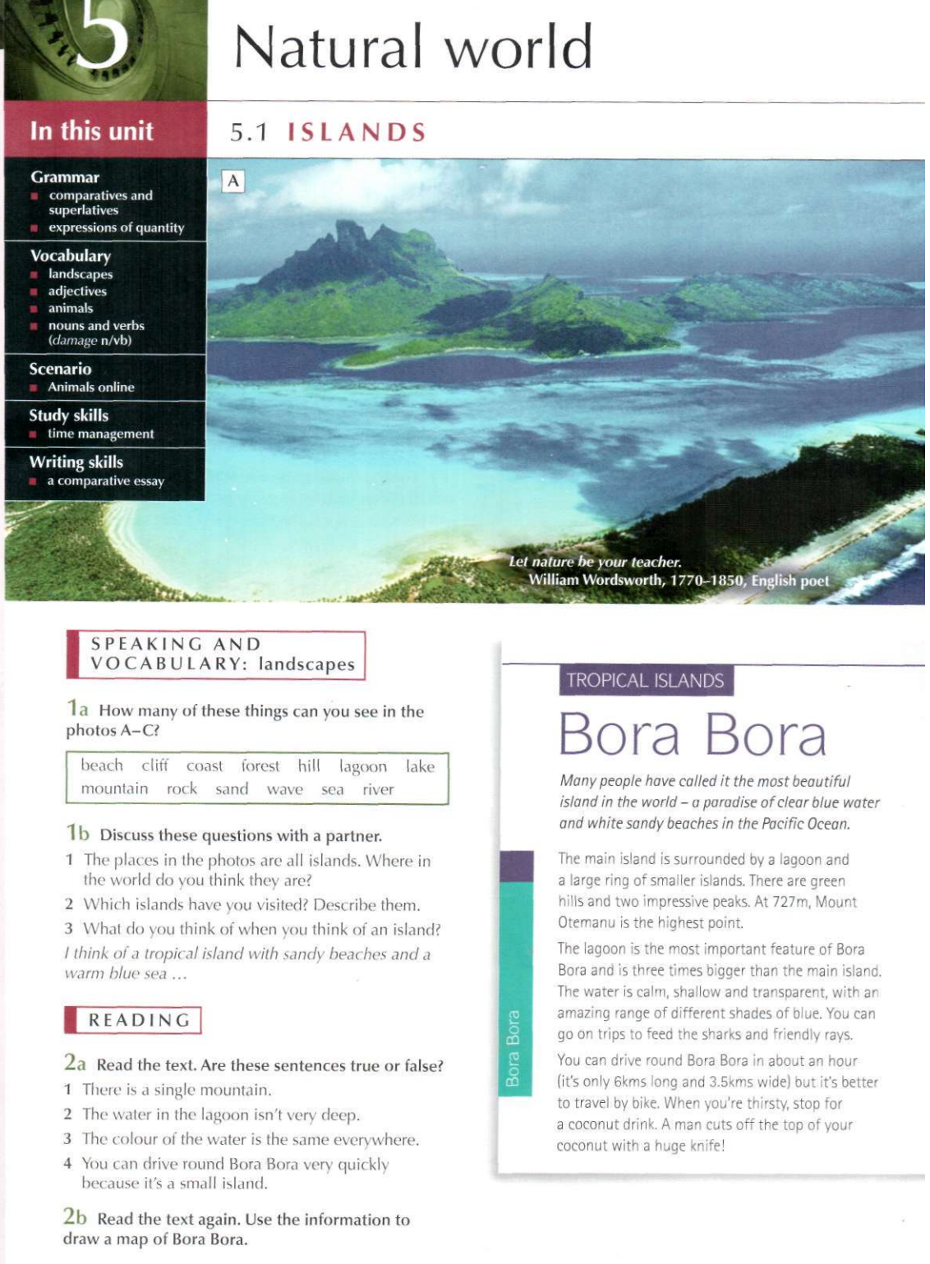

Lesson plan:
Think about how you would teach this and write a brief description of the process using the headings below. How can you ensure the students are speaking as much as possible?

The vocabulary
The discussion
The reading

Learning English
Consider what problems learners are likely to have with English. If possible, use your own experience of learning a language, or helping people to learn English. Write about 200 words. You can comment on some or all of the following areas: pronunciation, grammar, idioms, vocabulary and cultural features.
Learning English:

