Extending INSIDE the UK (Permission to Stay)
Online Application Form Guide
This guide provides step-by-step guidance for students aged 16 or over completing the Student visa online application form to extend your visa from within the UK.

This Guide was kindly Authored and shared by Exeter University

Contents

Getting started 5
Getting started continued 7
- Start: Your nationality 8
Your location 10
Other Home Office applications 10
Register your email & Registration email address 11
Immigration adviser 11
- Application: Your name 12
Your contact email 13
Your telephone number 13
Your postal address 14
Your gender and relationship status, Your nationality, country and date of birth, Your passport 15
Your identity card 15
Your other nationalities 15
Your current UK immigration status 15
Your current visa or leave to remain 15
Revocation, cancellation or curtailment 16
Your most recent leave 16
Police registration 17
Time in the UK 18
About your first parent, About your second parent 19
Biometric residence permit (BRP) 20
Your National Insurance number 21
Driving licence 21
World travel history and details of your world travel history 21
Previous evidence of English language ability 22
Immigration history 23
Breach of UK immigration law 23
Medical treatment in the UK 24
Public funds 25
Local authority care 25
Convictions and other penalties 26
War crimes; Terrorist activities, organisations and views & Extremist organisations and views 27
Person of good character 27
Your employment history 27
Sponsor license number, address & details 28
Academic Technology Approval Scheme (ATAS) 29
Current or past official financial sponsor 29
Future official financial sponsor 30
Course information 31
Course dates 32
Doctorate Extension Scheme 32
Accommodation payments 33
Course fees 34
Student Loan 34
Maintenance funds 35
Your Confirmation of Acceptance for Studies (CAS) 36
- Stop and book an appointment with International@CampusLife 37

Getting started

This form is for a Student visa application.
For adding dependants, see this guide.

How long it takes you to complete the application will depend on your particular situation. You will be able to save your application and come back to it at another time if you need to (click ‘Return to this application later’). If you are inactive for 25 minutes you will be automatically logged out. To return to your application, find your email from UKVI:

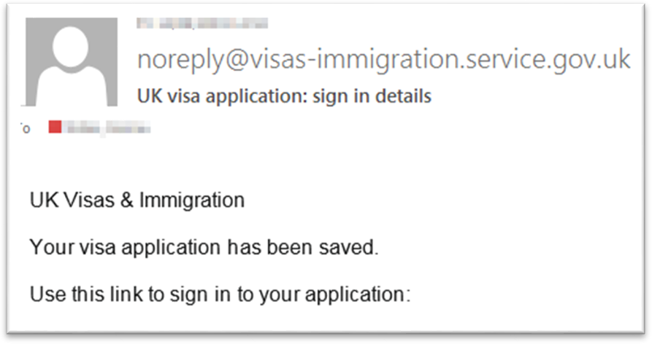Click on the link, enter your password and resume your application

Answer each question fully and truthfully. Failure to declare something on your form will be seen by UKVI as deception, and will result in this application (and possibly future applications) being refused. Providing the correct information will not automatically lead to a refusal.
Not every question is covered in this guide. If you can’t find an answer, contact us on visaadvice@exeter.ac.uk

The online application form is accessed here:
https://www.gov.uk/student-visa/extend-your-visa?step-by-step-nav=cafcc40a-c1ff-4997-adb4-2fef47af194d

Getting started continued

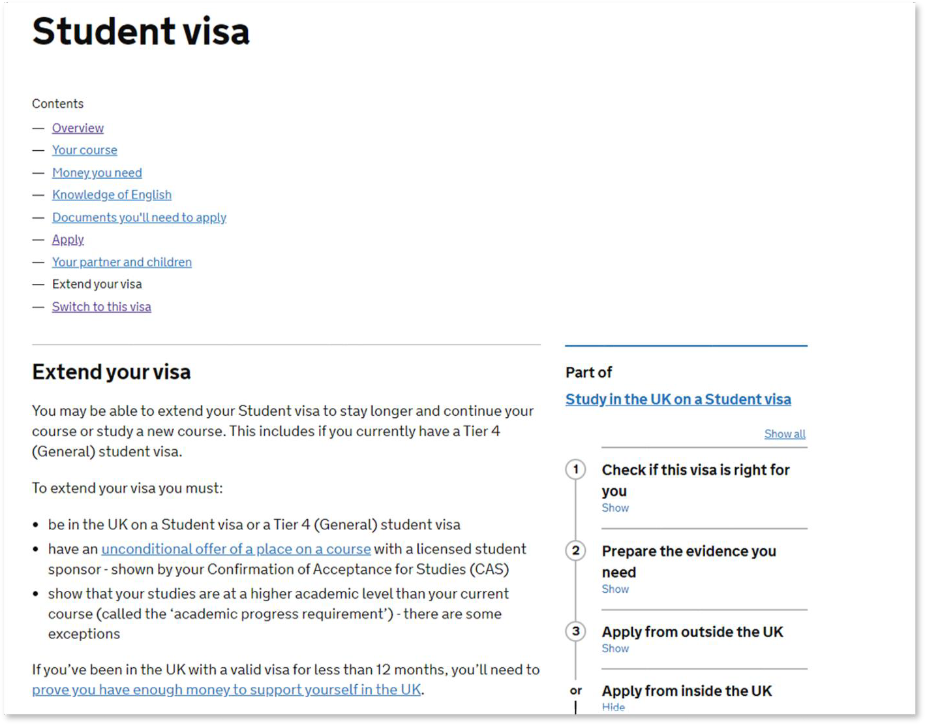
- Read the information on the introductory screen, and choose ‘Start now’ to begin your application.

If you have already set up your application, follow the instructions on page 4 to return to your application.

- Start: Your nationality

  - 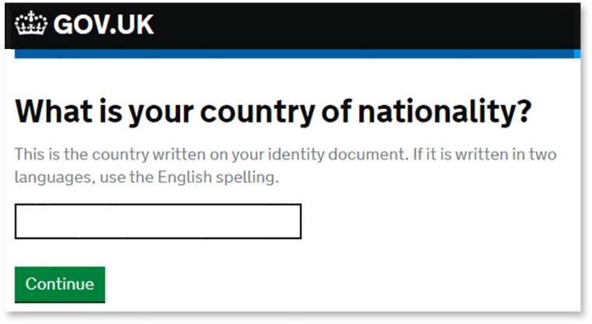Type your nationality

GOV.UK Visas and Immigration
mlJ This is a new service ·your willhelp us to improve It.
Student

Apply to extend or switch to Student.

Howtoapply
To apply to extend or switch to a Student you need to:

    - fillintheapplication form
    - have your documents ready
    - pay the application fee
    - pay the health surcharge
    - have your biometrics taken (fingerprints and a photo)

  - Read the information on this page and choose
‘Apply now’

Page 9
Page 9
Find more information on the requirements for a Student, including the documents you will need to submit with your application.

How long it takes you to complete the application will depend on your partic situation. You will be able to save your application and come back to it
if you need to.

If you are inactive for 25 minutes you will be automatically logged out.

Postgraduate studies
If you are taking a postgraduate course in certain subjects you might need an Academic Technology Approval Scheme (ATAS) certificate. Find out if you need an ATAS certificate.

Your location
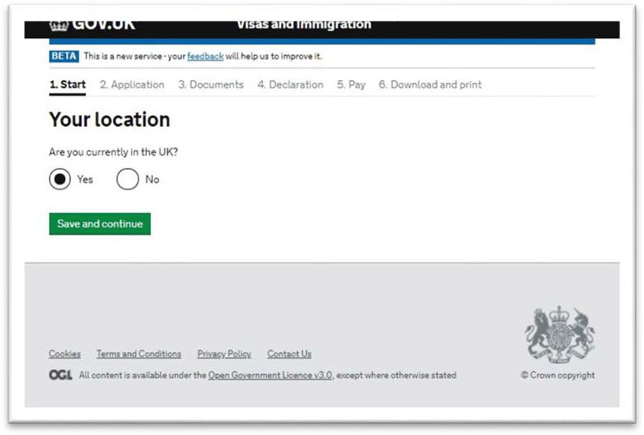
- Confirm you are currently in the UK
This form and guide is only for
people applying to extend their visa within the UK.

Other Home Office applications

- 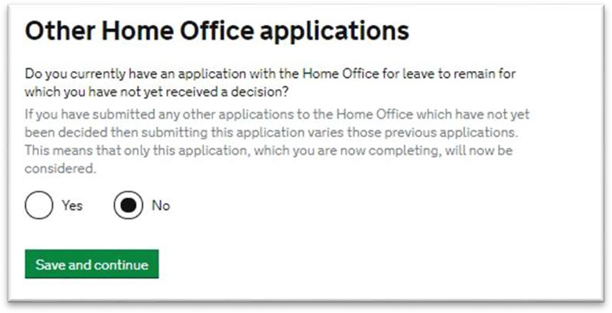Confirm if you have any other applications with the Home Office awaiting decision.
If you do, speak to us first.

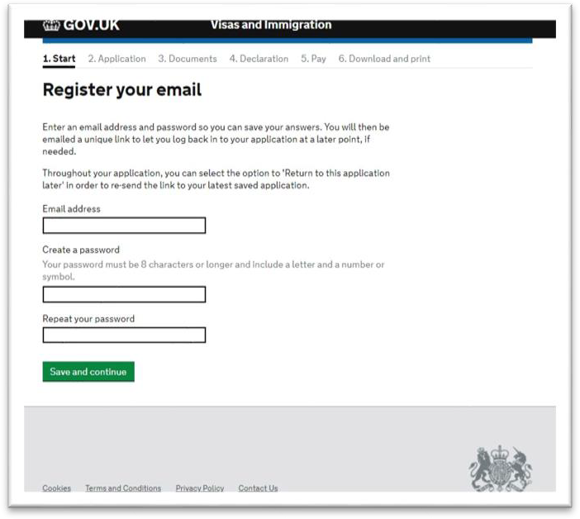Register your email & Registration email address

Immigration adviser

- Enter a valid email address and create a secure but memorable password.

You will be emailed a link to log back into your account. Keep this email safe to avoid having to start your form all over again!

- Verify the email account via the link that will be emailed to you.

Confirm this email address belongs to you (the applicant). You can add an additional email address if you wish.

- 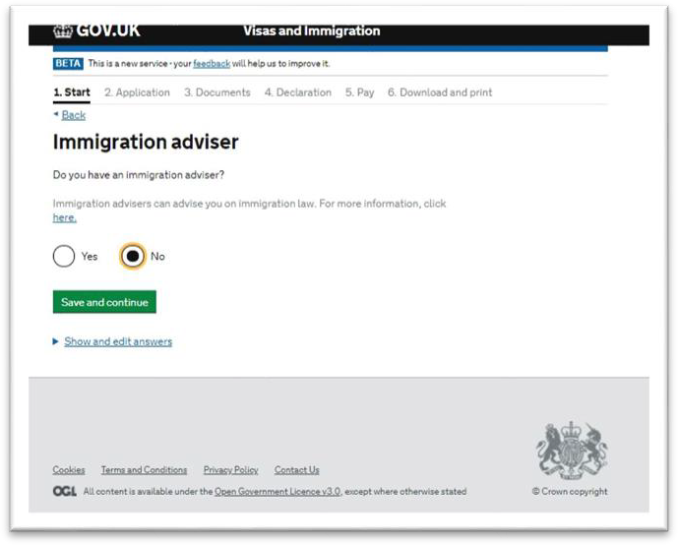Answer ‘No’ to having an immigration advisor, unless you are receiving advice from a registered Immigration Adviser outside of the University.

- Check your answers and click ‘Continue’

- Application: Your name

  - 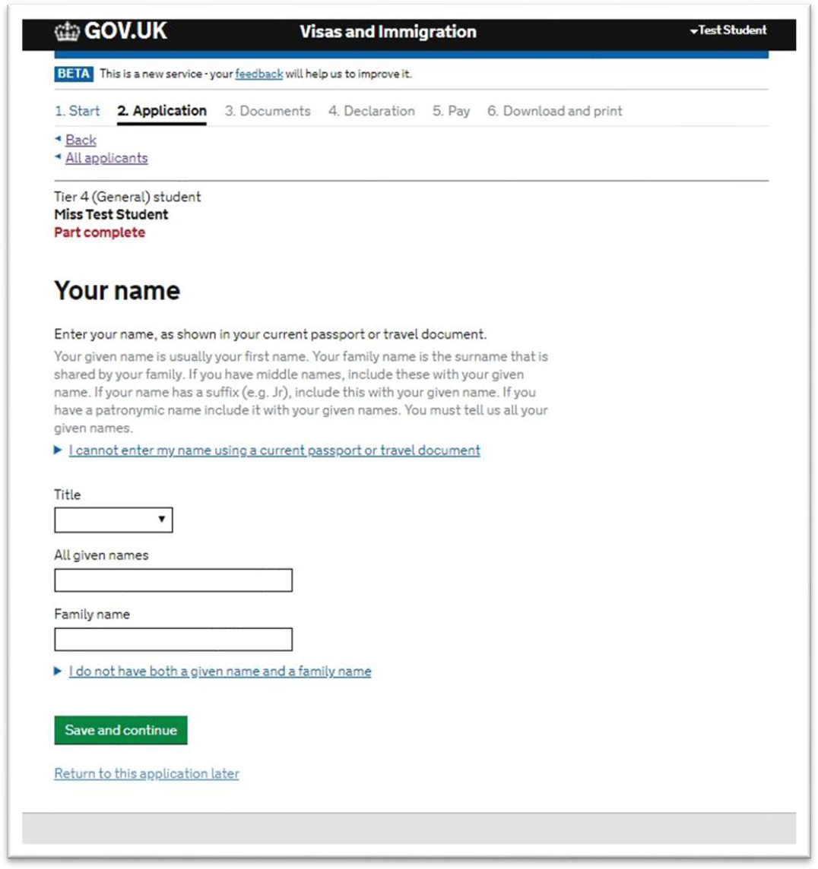Answer the questions about your names, exactly as they appear on your passport or travel document. Also include any other names you have been known by.

Your contact email

- 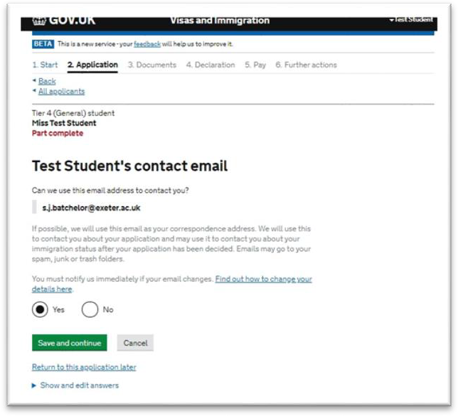Confirm the email address can be used to contact you.

If you want to add an alternative contact
email address, click ‘No’ and add it in to the
box that appears.

Your telephone number

  - 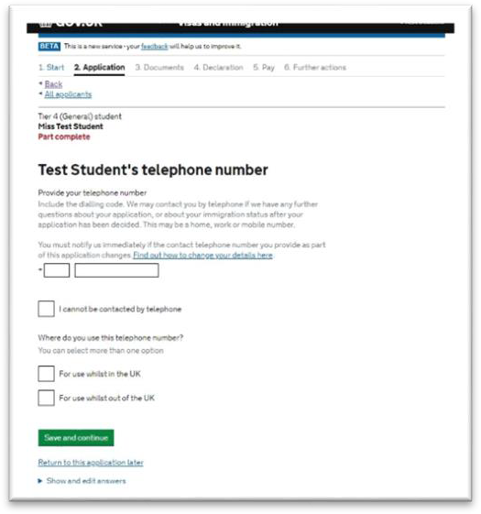Enter your contact phone number if you wish to be contacted via phone, and confirm if you use this number in and outside of the UK.

Your postal address
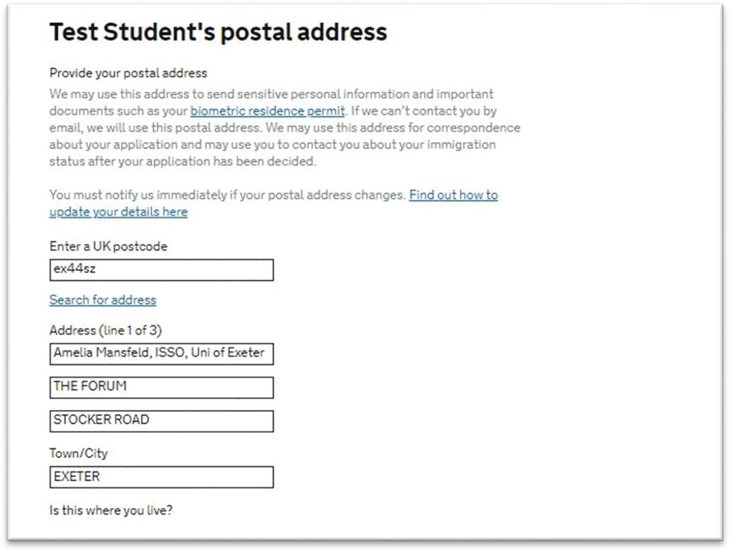

- Please enter the university’s address as your
postal address:

Swansea University
c/o Student Information Officer
ICL -MyUniHub Desk – Singleton Park Library
Singleton Park Campus
Swansea
SA2 8PP
Swansea

  - Tick ‘No’ to ‘Is this where you live?’ and enter your accommodation address and the month and year you started living there.

Your gender and relationship status, your nationality, country and date of birth, Your passport
- Answer the questions about your gender, relationship status, nationality, passport details and so on in full.

Your identity card
- Enter details of your national identity card even if you are unable to present your card. If you don’t have one at all, click
‘No’.

Your other nationalities
- You can add details for multiple nationalities and passports that you hold.

Your current UK immigration status
- Click ‘Yes’ to confirm that you currently have a visa or leave to remain in the UK, and confirm the type (likely Tier 4 (General) leave to remain). If you do not have a valid visa for the UK, please contact us for advice.

Your current visa or leave to remain
- Enter the start and end date of your current visa or leave to remain.

You must submit your application before your current visa expires. If you are close to this date, or if this has passed, you must contact us as soon as possible for advice.

Revocation, cancellation or curtailment
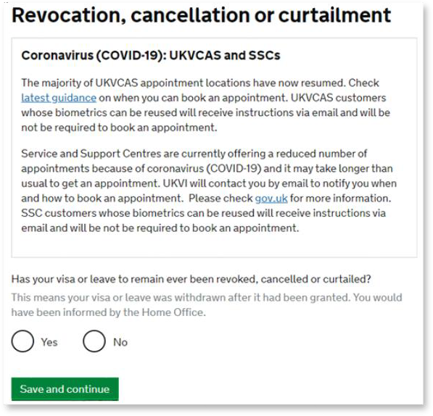
- Confirm if your visa has ever been revoked, cancelled or curtailed (shortened).
Listing details of this will not
automatically mean your application is refused. However, failing to disclose this will likely mean you are refused.
Be truthful.

Your most recent leave

  - 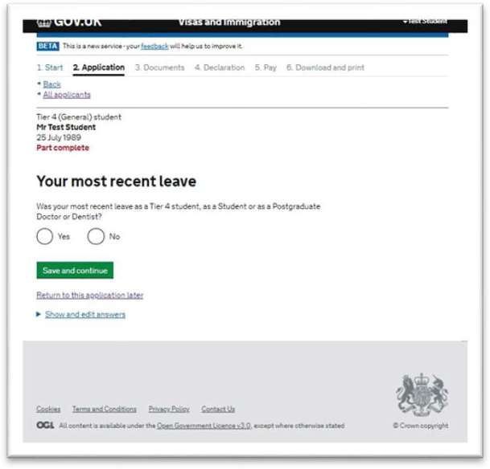Answer the question about your last leave (visa) granted. For most, this will be answered as ‘Yes’ if your most recent visa was a Tier 4 student visa.

Police registration

- 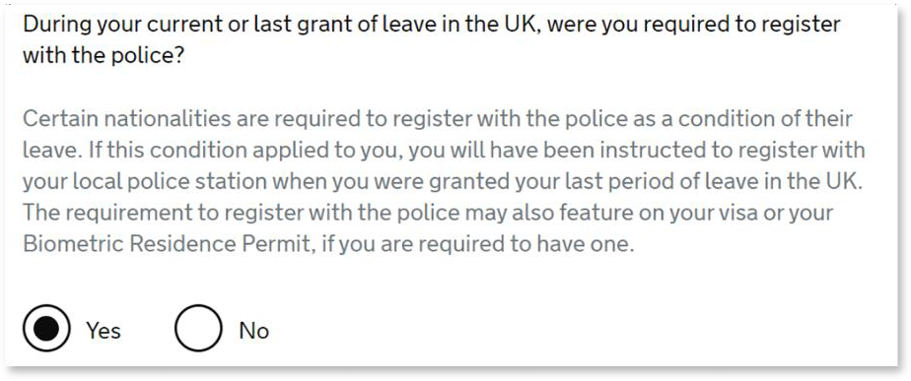Students of certain nationalities will be presented a screen asking about police registration.
- Confirm if you were required to register with the police as part of your last leave.

Certain nationalities should be required to register with the police. You can find out more about this on our website.

Take this opportunity to find your police registration certificate and update it if necessary.

Time in the UK

  - 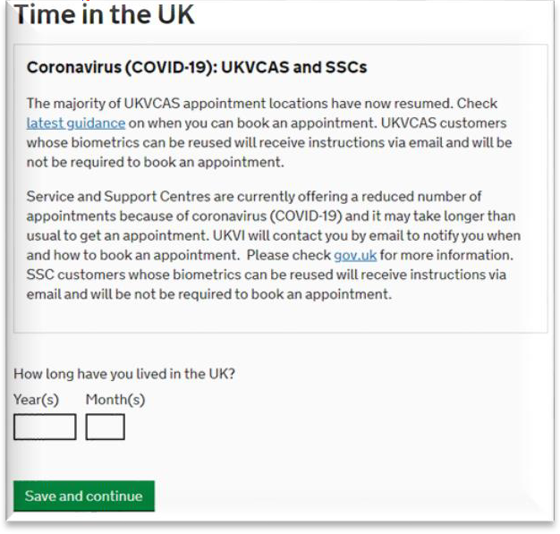Answer the question about how long you have lived in the UK.

About your first parent, About your second parent
- Answer the questions about your parents’ names, dates of birth and so on in full.
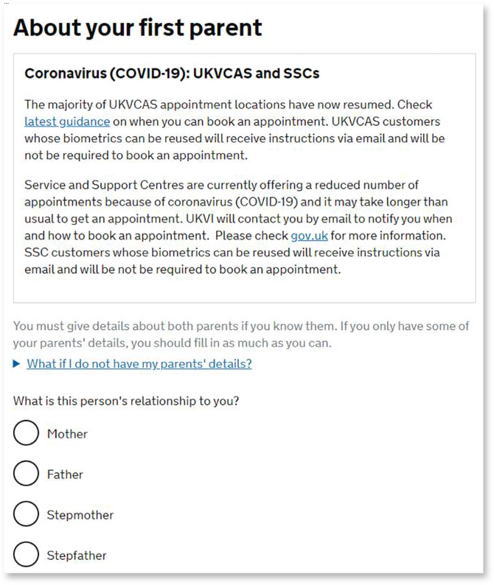

  - If you are under 18 years old, you will be asked for further details about who your parent(s)/guardian(s) are, and who has parental responsibility for you.

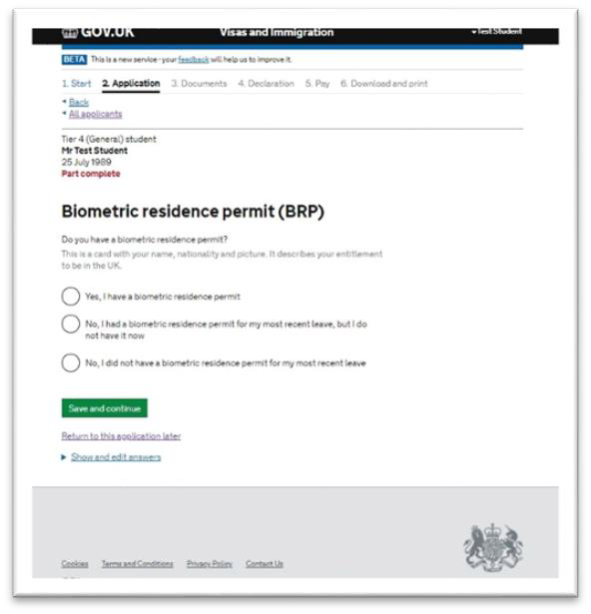Biometric residence permit (BRP)

    - Choose the applicable option regarding your BRP.

If your current visa is for less than 6 months, you are unlikely to have a BRP and instead your visa appears as a vignette (sticker) in your passport.

If you have a BRP, you will need to enter the BRP number (top right hand corner).

Your National Insurance number
- Enter your National Insurance number if you have one, or tick the box to indicate you do not have one.

Driving license
- Answer the question about whether you hold a UK driving license.

World travel history and details of your world travel history
- Answer the question about whether you have travelled to any other countries in the last 10 years, and if you have answered ‘yes’, provide details of each visit. Provide details of each visit as accurately as possible, but an estimate of dates is ok. You can add multiple visits.

Previous evidence of English language ability

  - 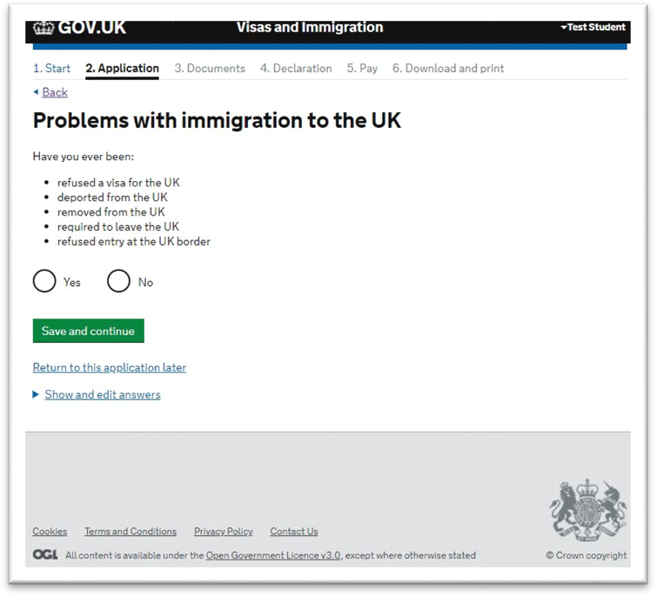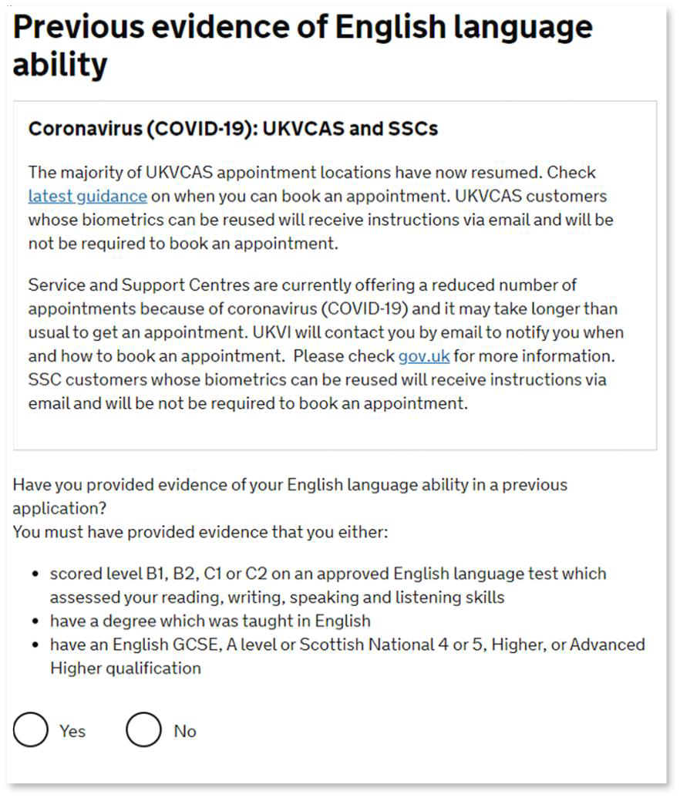Only choose ‘yes’ if you are extending your
visa for your current programme.

Everyone else should choose ‘no’.

Immigration history
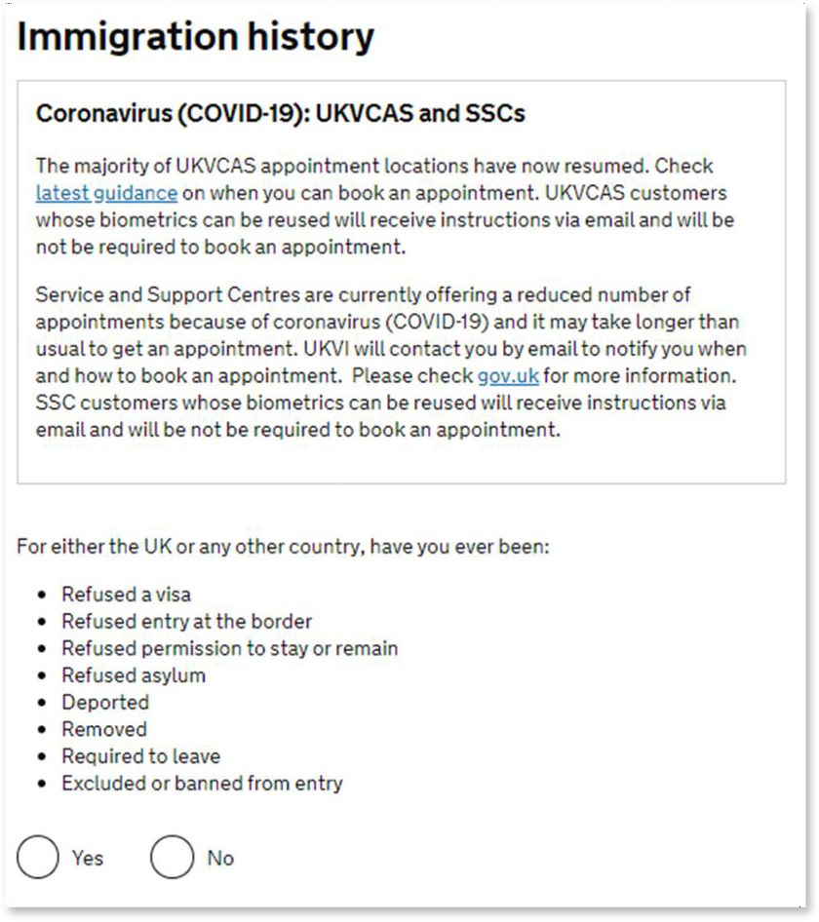
- Answer the questions in this section truthfully.
Selecting ‘Yes’ will allow you to explain more
details of what happened, including a free- text box.
You can add multiple immigration problems.
Listing details of a refusal will not automatically
mean your application is refused. However, failing to list a refusal will likely mean you are refused.
Be truthful.

Breach of UK immigration law
Answer the question truthfully. Selecting ‘Yes’ will allow you to explain more details of what happened, including a free- text box.

Medical treatment in the UK

- 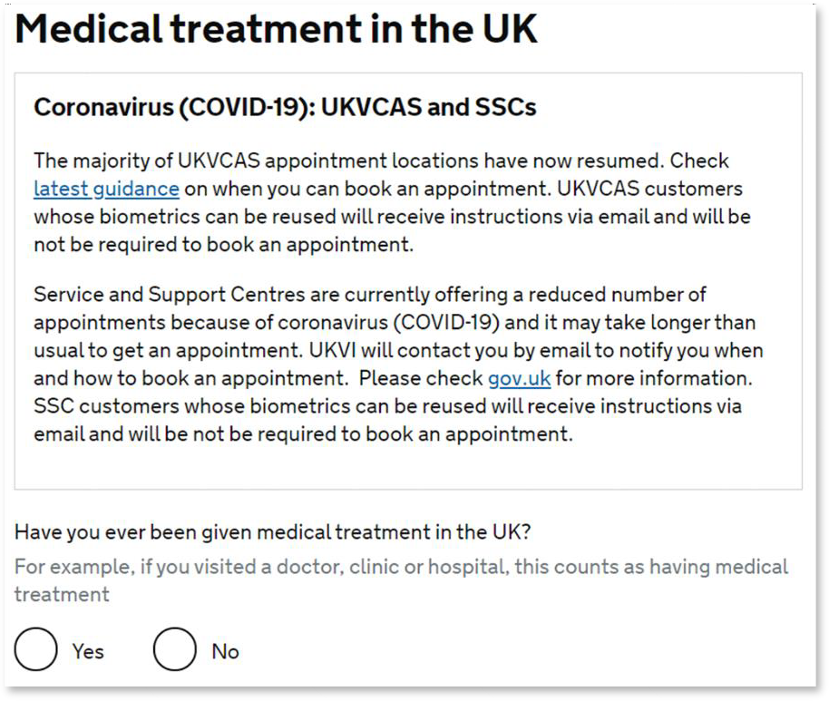Choose ‘no’, even if you registered with a doctor but never received medical treatment.
- Choose ‘yes’, if you’ve ever had an appointment with, or been treated by a doctor/nurse at a doctor’s surgery or clinic, health Centre, walk-in Centre or hospital.
- If you answer yes, you should answer the question about whether you were asked to pay for your treatment.
- If you didn’t have to pay for treatment, you
will be asked to provide details.

You may find these details helpful:
Student Health Centre, NHS Walk-in Centre, Penryn Surgery,
Reed Mews, Unit 4, Saracen Way,
Streatham Drive, 31 Sidwell Street, Penryn TR10 8HX
University Campus, Exeter, EX4 6NN
Exeter, EX4 4QP Falmouth Health Centre,
NHS Walk-in Centre, Trevaylor Road, Royal Devon & Exeter Hospital, Wonford Hospital, Falmouth, TR11 2LH Barrack Rd, Exeter, EX2 5DW
Exeter EX2 5DW

Swansea University Health Centre, Ground Floor
Penmaen Singleton Campus Swansea, SA2 8PP

Public funds

  - 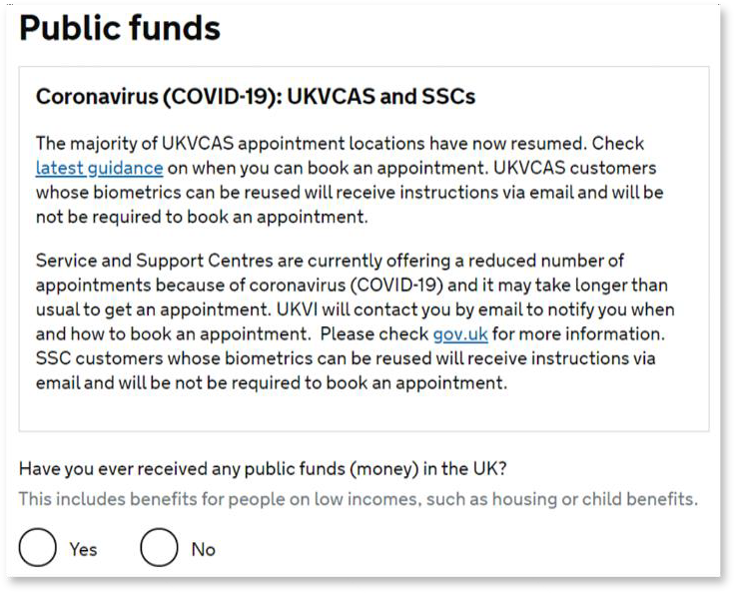If you answer yes to having received public funds within the UK, you will be asked to provide further detail.

Local authority care

- 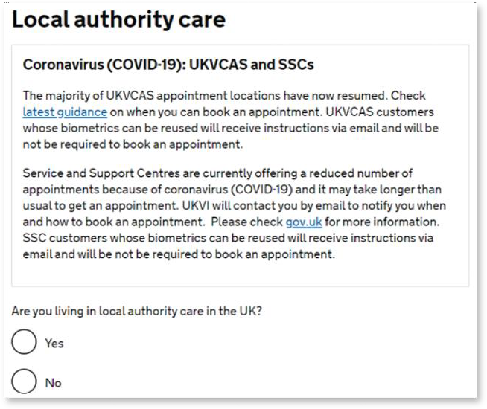If you live in university or private
accommodation , choose ‘no’

Convictions and other penalties

- 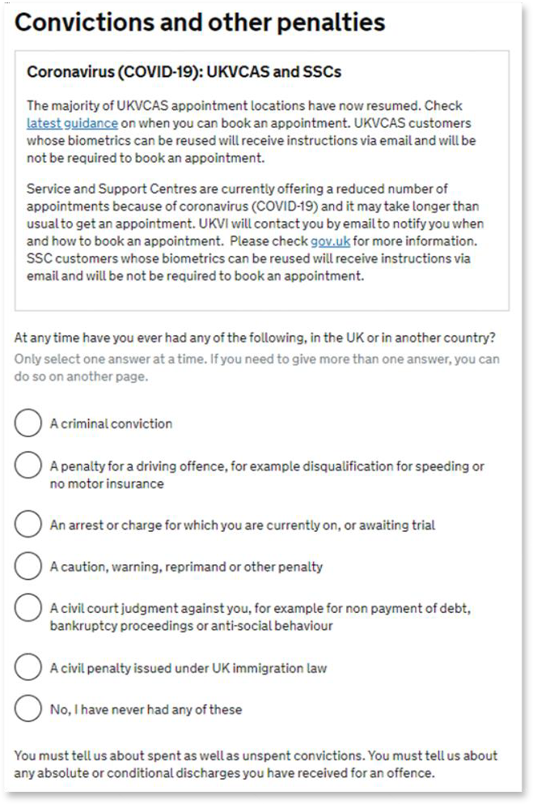Answer the questions truthfully, including information for ANY country (not just those from within the UK).

Selecting an option from the list directs you to another page with a free text box where you can add further details.

War crimes; Terrorist activities, organizations and views & Extremist organizations and views
Read the definitions then answer the questions truthfully and confirm you have read and understand the guidance. If you
answer ‘yes’ you will be provided with an opportunity to give more details.

Person of good character
Answer the questions truthfully. If you answer ‘yes’ to any question, you will be provided with an opportunity to give more details.

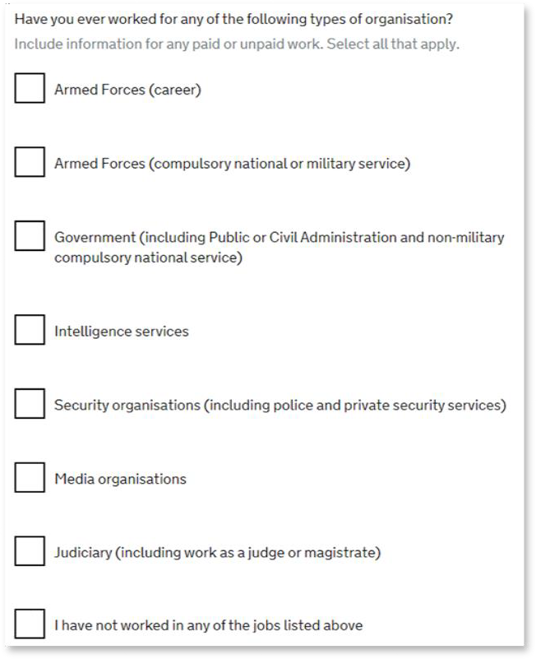Your employment history

  - If you have worked in any of the types of organizations listed, you can provide further information about your role, the name of the organization and the dates of your employment

Sponsor license number, address & details

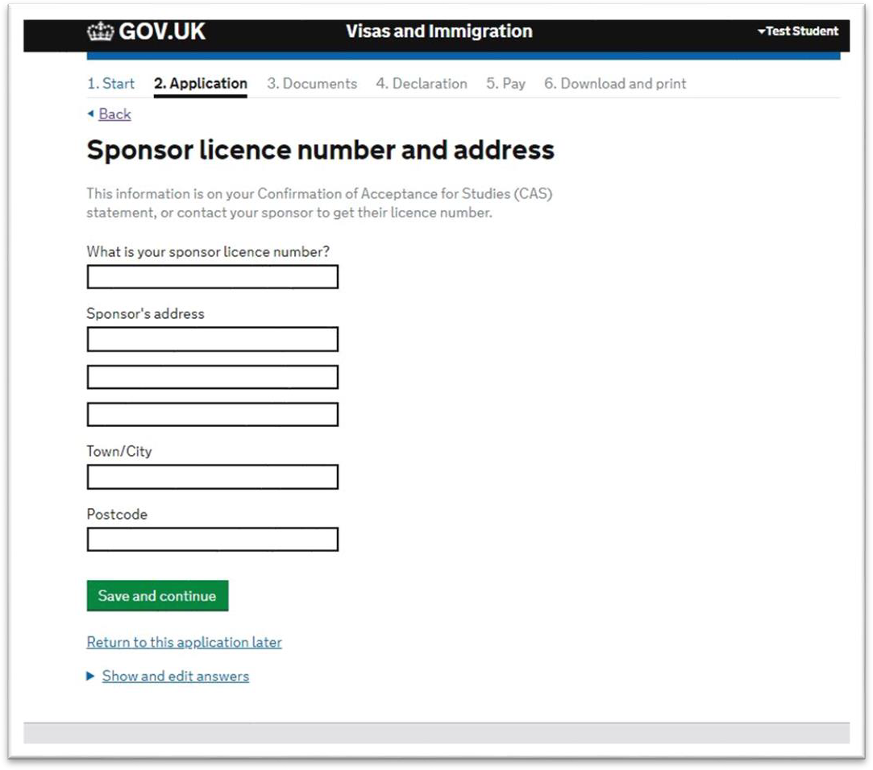Student Sponsor license number:
18UEHPGX4
3FMMCWWY2

Address of sponsor (use the same address for all campuses):
University of Swansea, Singleton Park, Swansea,
SA2 8PP
University of Exeter
Northcote House Queens Drive Exeter
EX4 4QJ
  - Place of Study:
Higher Education Provider with a track record of compliance

Primary site of study:
Singleton campus: select ‘Yes’
Bay campus: check the details on your CAS Statement and edit if necessary.

UCAS details:
Click ‘Yes’ for undergraduate courses and provide your UCAS number, otherwise click ‘No’.

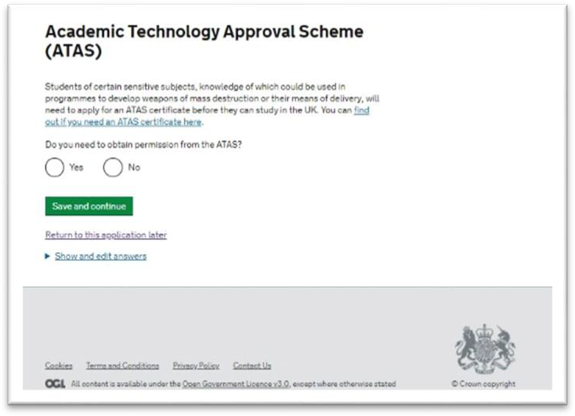Academic Technology Approval Scheme (ATAS)

- Check to see if your course requires an ATAS certificate. If so, make sure you have applied and know your reference number. We can’t issue your CAS without this.

ATAS is free to apply for, but can take up to 6 weeks for a response. Be sure to apply in plenty of time.

- 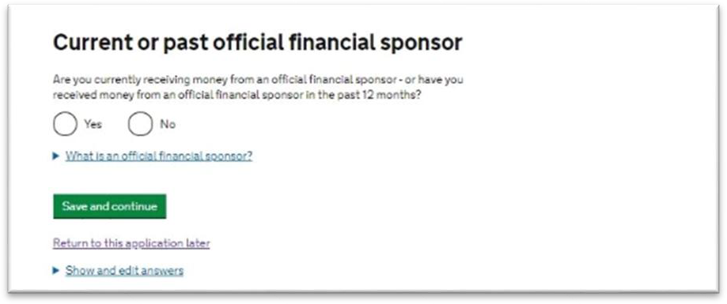If you are currently, or have been within the past 12 months, sponsored by your government, an international company or university, you should tick ‘Yes’.
Current or past official financial sponsor

You will need to show a letter from your sponsor giving permission for you to continue your studies in the UK.

Your parents do not count as official financial sponsors.

  - 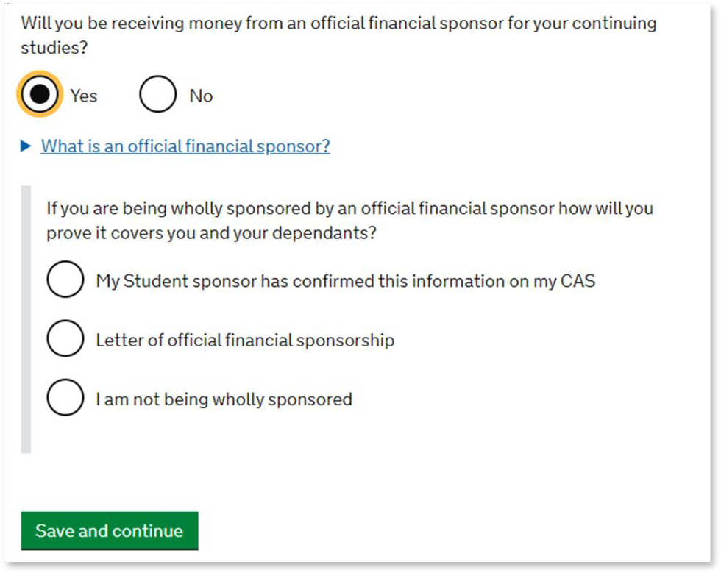If you are sponsored by your government, an international company or university, you can tick ‘Yes’, and select how this will be shown.
Future official financial sponsor

You will need to select ‘Letter of official financial sponsorship’ unless you are sponsored by the University of Exeter and this is detailed on your CAS.

Your parents do not count as official financial sponsors.

Course information

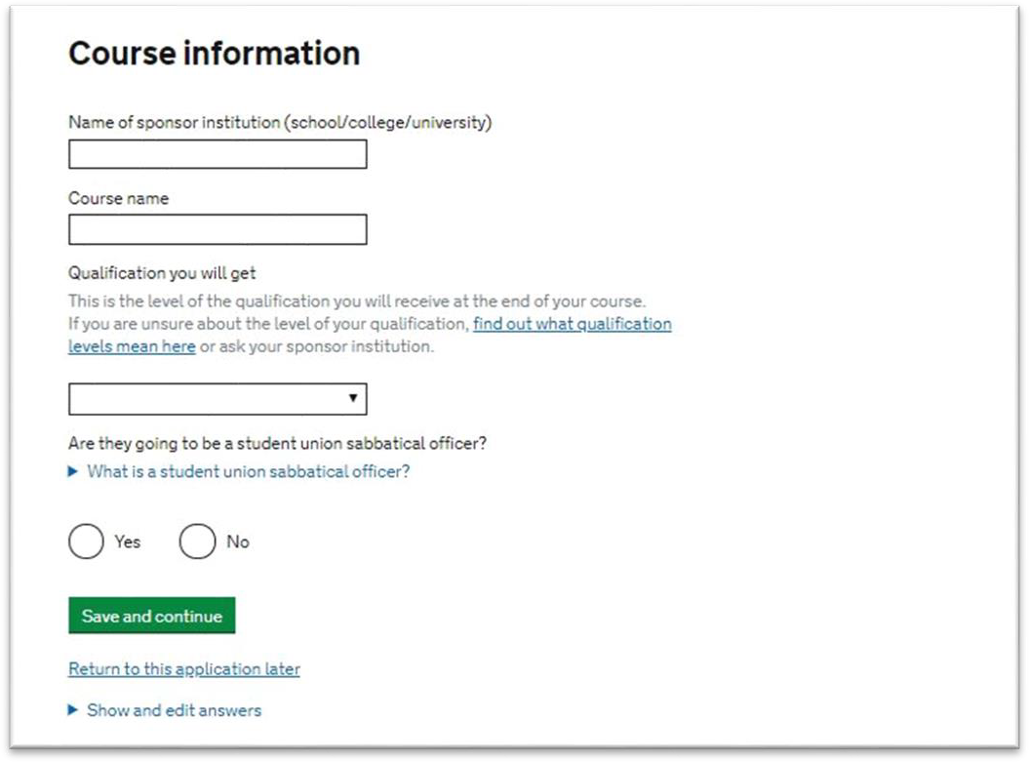Use your CAS to help you answer the following questions:

Name of sponsor institution:
University of Exeter

Course name:
Enter your course name as it appears on your CAS

Qualification you will get:
This is the RQF level listed on your CAS.

Sabbatical officer:
Answer ‘no’ unless you are an elected Guild, or Students’ Union, President

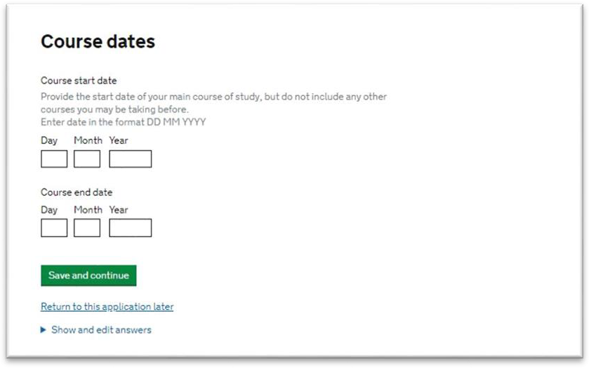Course dates

Doctorate Extension Scheme

- Enter your course dates exactly as they appear on your CAS.

- 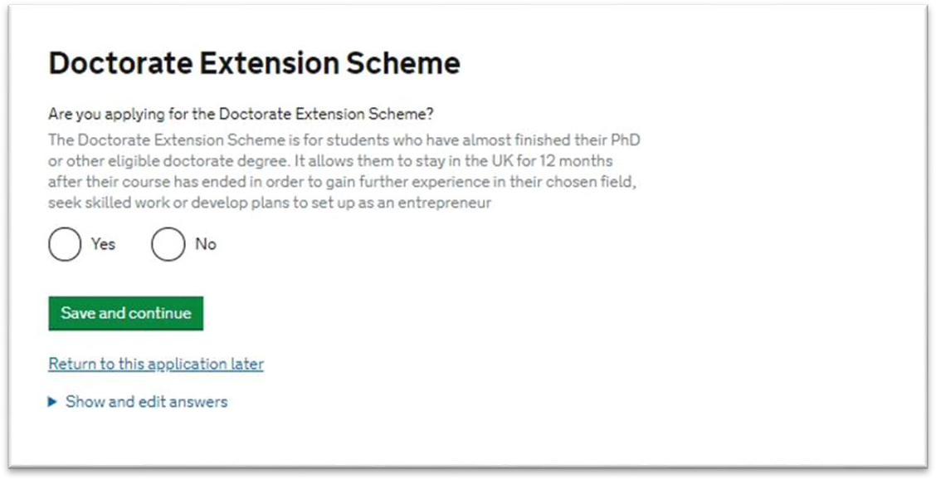Confirm if you are applying for the Doctorate Extension Scheme (DES). You will know if you are as you will have spoken to someone in our team, and will have a specific CAS for the scheme.

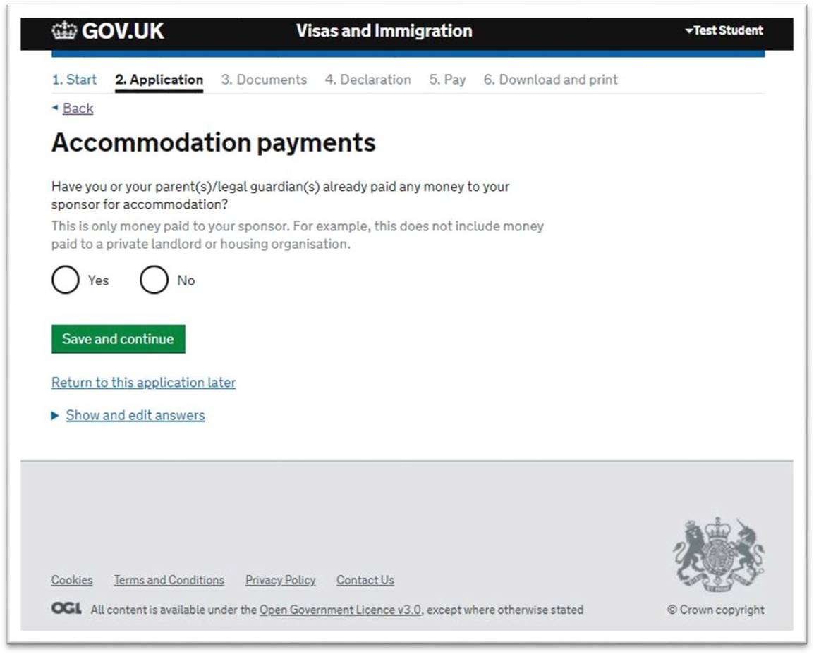Accommodation payments

  - If you are under 18 years old, you will be asked whether you will be in a guardianship arrangement at any point while you will be in the UK.

Only payments to the University of Exeter can be included here. Private accommodation cannot be included.

- Choosing ‘Yes’ brings up further options to say how much you have paid, and if this is confirmed on your CAS, or if you will show receipts.

Remember to ensure your CAS is up- to-date if you have recently paid money towards your accommodation.

You can deduct a maximum of
£1,265 of any money you have paid for University accommodation from the total living expenses money you need to show. If you have paid more than this amount, still enter the full amount you have paid into this box.

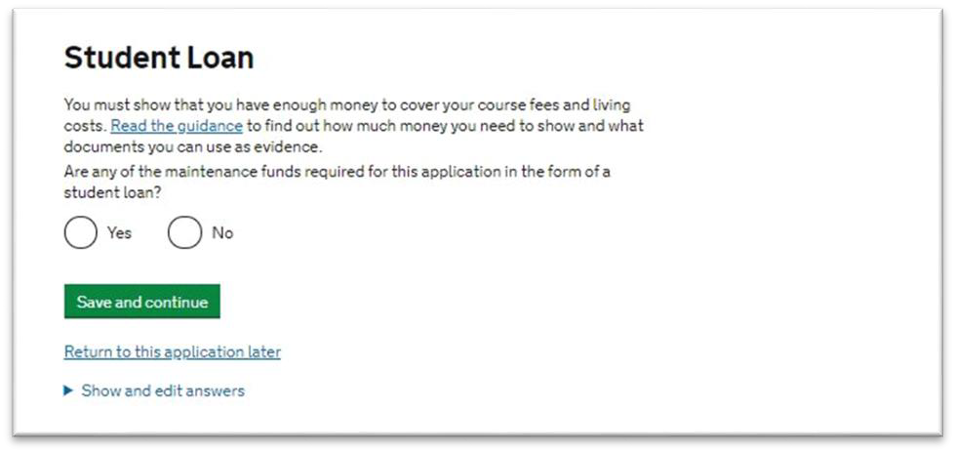Course fees
Page 34
- Confirm if your funds are in the form of a student loan.
If you choose ‘Yes’ you will be asked
if you have already received this loan.
Page 34

Student Loan
The course fees must match the amount written on your CAS.

  - 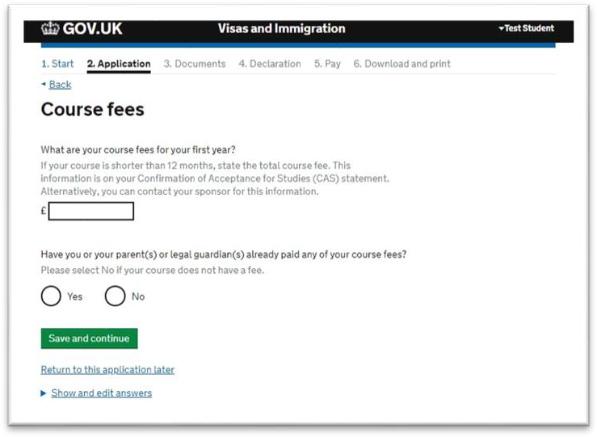If you have made a tuition fee payment, choose ‘Yes’. This brings up more options to confirm how much has been paid, and if this is confirmed on your CAS, or by receipt.

Remember to ensure your CAS is up- to-date if you have recently paid money towards your tuition fees.

If you are submitting your application with International Student Support have your payment receipt available during your appointment and your CAS will be updated by an adviser.

    - 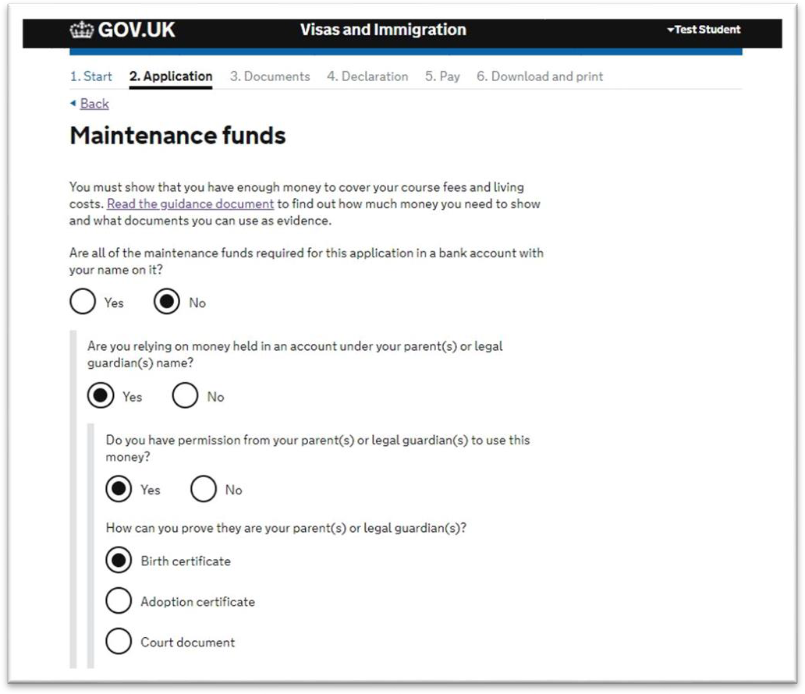You can find out about the maintenance requirement here.
Maintenance funds

Sponsored students should answer ‘Yes’ to the funds being held in your name.

    - If the funds are not held in your name, these must be held under your parent(s) or legal guardian(s) name.

The form will then prompt you to confirm that you have permission and proof of your relationship.

Your Confirmation of Acceptance for Studies (CAS)
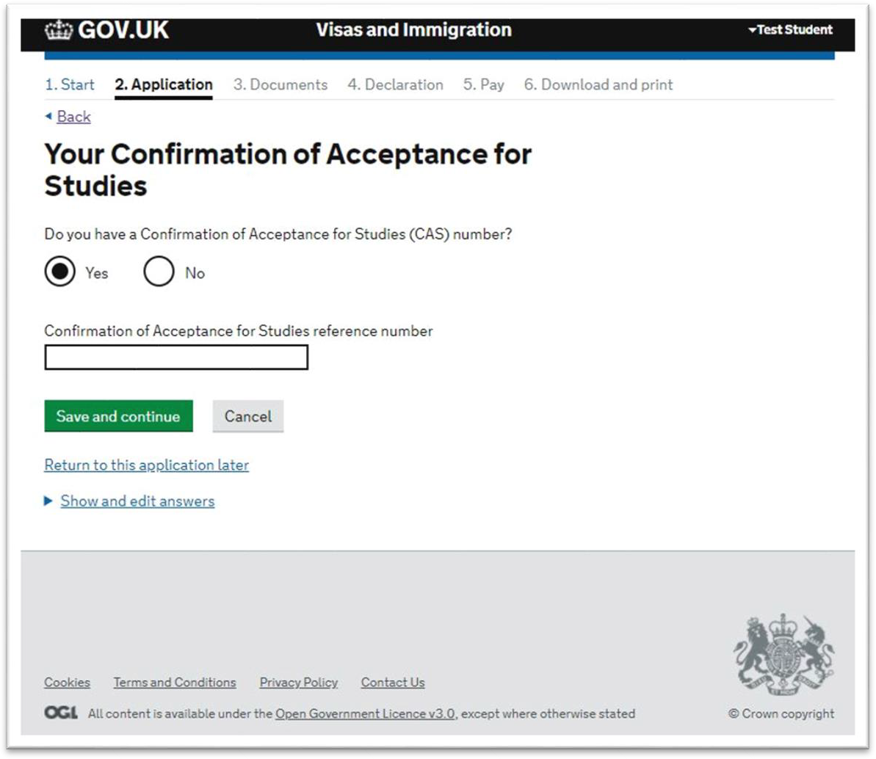
Do not apply before you are
issued with a new CAS number. You cannot progress any further with your application without this.
Do not use a CAS number from a
previous course; you must use a
new CAS for each application.

Stop and book an appointment with International@CampusLife
STOP!
Stop when you reach the section below where you can check your answers.
DO NOT MAKE ANY PAYMENTS
Now book an appointment* to see the International Student Support team.
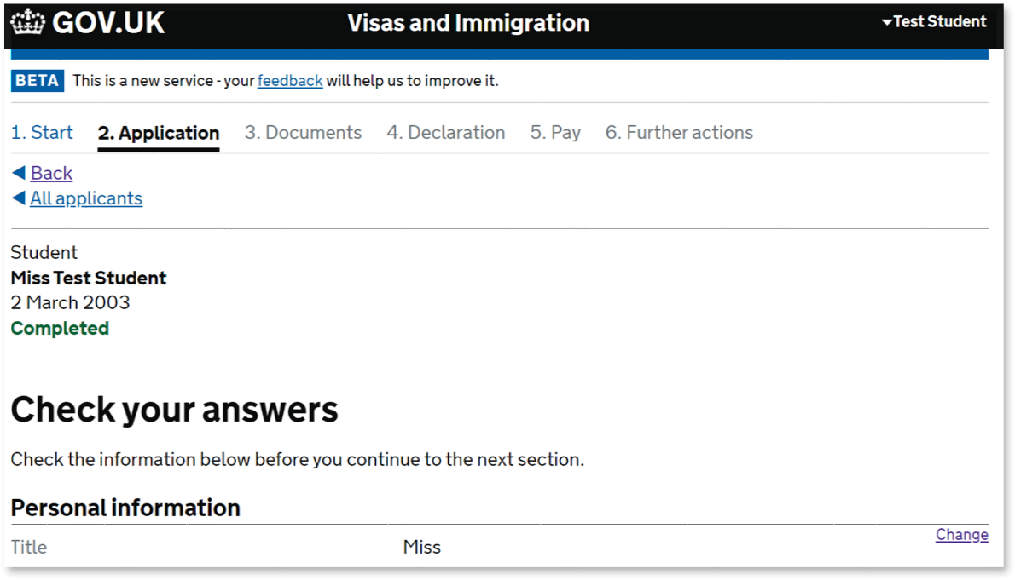
You will need to have the following ready for your appointment:
  - your log in details to access this application
  - a credit or debit card to pay for your application
  - scans of all your supporting documents

