Title: My Visit to Protect Children (Suojellaan Lapsia): Working Together to Understand and Combat Child Sexual Abuse Offenders.
By Rosie Marsh-Rossney (Swansea University ESRC DTP-funded PhD student)
Blog text:
“Child sexual exploitation and abuse online is one of the most urgent and defining issues of our generation.”
– WeProtect Global Alliance (2021)
Child sexual abuse is a prevalent issue in our digital age, but hope can be found in the growing effort to combat this threat through research and direct action by institutions and organisations like Protect Children (Finland) and Project DRAGON-S (UK).
I am a doctoral researcher at Swansea University in Wales (UK) investigating how offenders talk to each other in online paedophile communities from a forensic-linguistic perspective. Forensic linguistics is the application of language analysis tools in criminal contexts, such as the language of courtrooms, language analysis in legal cases like plagiarism, and language appearing as forensic evidence in a crime. In my research I examine how offenders form online networks where they can trade Child Sexual Abuse Material (CSAM), share advice with each other, attempt to normalise paedophilia, and rationalise their behaviour. I also investigate how these communities are maintained, participated in, and regulated by members. Within these illegal interactions offenders construct identities for themselves (deciding how to portray themselves to others) and use certain types of language to perform these identities, to navigate social etiquette, and to persuade others of their perspectives. They engage in relationships with one another and build trust to maintain the security of these criminal groups. It is these types of interactions which I study, specifically those occurring on clear-web social-media platforms.
These online communities pose a threat to the safety of children by providing a platform populated by likeminded users who can support one another’s criminal behaviours, enabling offenders searching for CSAM to rationalise and justify their attractions amongst an audience who reaffirms them. Research by Protect Children suggested that CSAM-offenders on the dark-web who claimed to be in contact with other offenders online were more likely to have sought sexual contact with children. Protect Children thus argued that ‘online interaction with peers may facilitate sexual violence against children’ (read the full report here). My research supports this assertion, revealing that the community can sometimes put offenders on an escalating trajectory leading them to become reliant on it for emotional support, access to CSAM, and validation. Due to the role these communities play, it is vital that research is undertaken into them, and strategies developed to combat them.
Protect Children investigated these offender communities, conducting unprecedented surveys of undetected offenders on the dark-web through their ReDirection project and, more recently, clear-web social media platforms. They pioneered this new approach to child sexual abuse prevention by directly asking active CSAM-offenders about their habits and how they access illegal material through their anonymous survey. This project also revealed that 46% claimed to be in contact with other offenders and 35% said they had been affected by the thoughts, feelings, or behaviours of other CSAM-offenders online. This overlap between our research areas led to a mutual interest in collaboration to disseminate our findings and see what practical outcomes could be developed from the research. To kick-off this partnership, I travelled to Helsinki in winter (2024) to visit the Protect Children team.
Shortly after arriving in their office and receiving a warm welcome from the team, I was given an overview of their impressive work in various groundbreaking projects, collaborations, and networks. It was heartening to see their vigilance raising awareness on social media, their dedication to peer support groups for parents and guardians, and their unwavering efforts to bring the focus back to child-protection and harm prevention at every stage. During my visit we shared our respective research and had productive discussions about key findings. I also joined the team for events such as the Council of Europe Barnahus final meeting in Helsinki. This hosted experts coming together to present a culmination of fascinating work on improving the experiences of victims seeking justice, including talks by Anna Ovaska and Katariina Leivo from Protect Children (where the new Barnahus unit video for child-victims was discussed). In the weeks leading up to their research publication and discussion event at the European Parliament in Brussels, I observed the team’s careful preparation to present the preliminary findings from their ReDirection survey (read the full report here).
Following this visit, myself and Professor Nuria Lorenzo-Dus presented at Protect Children’s ReDirection International Expert Webinar 2024 on criminal activity, risks, motivations, and trust in online offender communities. I am grateful to the entire Protect Children team for hosting me so generously and being open to working together. I am also grateful for the efforts of Professor Lorenzo-Dus, who heads up Project DRAGON-S in Swansea and supervises my research, for conceptualising this connection. It has been an informative, valuable experience.
We hope this collaboration can have a meaningful impact and encourage more international collaboration between academics, law enforcement, and organisations working towards the shared goal of child-protection. To further this aim, we are producing an upcoming report which looks at how child sexual abuse offenders portray themselves in clear-web paedophile community interactions and dark-web survey responses. This combines results from the ReDirection project and my PhD thesis to understand and compare how offenders present themselves, their motivations, and their offending to different audiences in different spaces online. An academic journal article on this topic is also in the works.
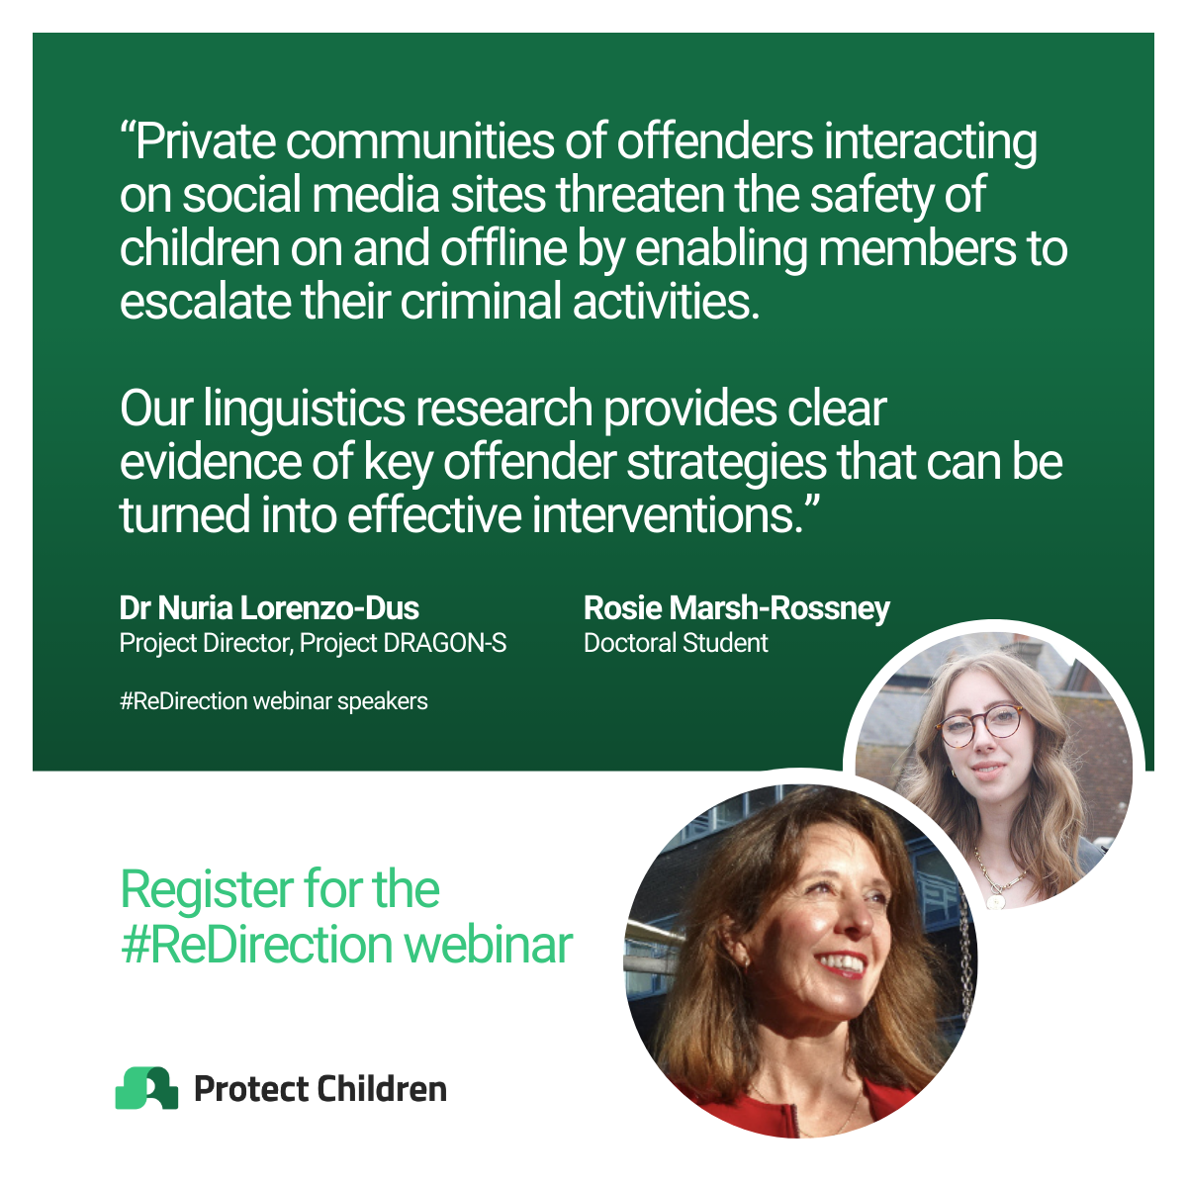

Protect Children (Suojellaan Lapsia ry) is a Finnish NGO founded by Nina Vaaranen-Valkonen which aims to prevent child sexual abuse, exploitation, and violence by taking a research-based holistic approach to advocacy work. The organisation works with professionals, governments, NGOs, offenders, families of victims, and survivors through research projects, support-groups, counselling, and international networks.

