
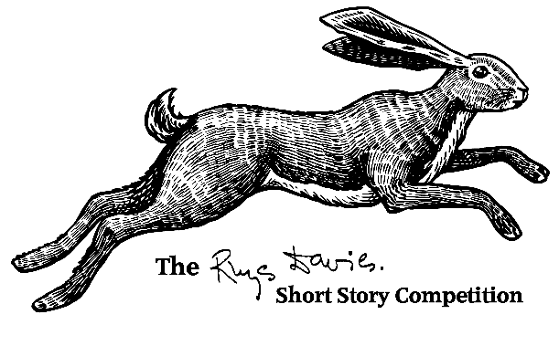
The 2026 Rhys Davies Short Story Competition
Entry Rules, Terms and Conditions

The Rhys Davies Short Story Competition recognises the very best short stories in English in any style and on any subject up to a maximum of 5,000 words by writers in / from Wales.
Entries must not have been previously published in print or online, including personal blogs or on social media, or been broadcast, or placed in a competition.

Originally established in 1991, Swansea University’s Cultural Institute is delighted to manage this prestigious award on behalf of The Rhys Davies Trust and in association with Parthian Books.
Born in Blaenclydach, near Tonypandy in the Rhondda, in 1901, Rhys Davies was among the most dedicated, prolific, and accomplished of Welsh prose-writers in English. He wrote, in all, more than a hundred stories, twenty novels, three novellas, two topographical books about Wales, two plays, and an autobiography.

Closing Date: Monday 16th February 2026 at midnight
2026 Judge: Tyler Keevil

**To be eligible, you must have been born in Wales, lived in Wales for 2 years or more or currently be living in Wales**

Awards
- 1st Prize - £1,000 sterling and publication in a short story anthology to be published by Parthian Books in 2026.
- Runners-up/Finalist Prizes - £100 each and publication in a short story anthology to be published by Parthian Books in 2026.

Please read the following Entry Rules and Terms and Conditions before submitting your entry. By submitting an entry, you acknowledge that you agree to the rules, terms and conditions outlined below.

For any queries, please email rdshortstory@swansea.ac.uk before submitting your entry.

- The Rhys Davies Short Story Competition recognises the very best unpublished short stories in English in any style and on any subject up to a maximum of 5,000 words by writers in / from Wales. Entries must not have been previously published in print or online, including personal blogs or on social media, or been broadcast, or placed in a competition.
- Entrants must have been born in Wales, lived in Wales for 2 years or more or currently be living in Wales.
- Entries open on 28th November 2025 and close on 16th February 2026 at midnight (British Standard Time). Entries received after this time will not be considered.
- The 2026 finalists will be announced in June 2026.
- The winner of the 2026 Competition will be announced in September 2026.
- All entries will be judged anonymously.
- The entry fee is £8 per story except for those awarded free entry places. When you pay your entry fee, a unique reference number will be generated. https://www.eventbrite.co.uk/e/2026-rhys-davies-short-story-competition-tickets-1430216158029. The reference number should be included in the relevant section of the online entry form.
- There are 40 free entry places available for low-income writers where earnings are £16,000 or less per year. These places will be issued on a first-come, first-served basis (one free entry place per person). Should you wish to apply for one of these places, please email: rdshortstory@swansea.ac.uk. There is no need to declare your income threshold.
- You may submit a maximum of two stories to this competition
- Entries must be submitted via the online form at https://forms.gle/asPp6G7aJKsweqPX6
- Entrant must be aged 18 or over on the closing date (16th February 2026).
- Employees of Swansea University, sponsors of the Competition, or other company or person involved directly with the administration of this Competition, or any members of their households are ineligible.
- A translation of a work originally written in a language or languages other than English is not eligible.
- AI-generated entries are not eligible. You may not use Artificial Intelligence, or the AI tools of other apps, to aid in any part of the story's creation. Spellcheckers and word processors are permitted. By submitting, you are formally declaring that no AI has been used.
- Entries should be uploaded in PDF, .doc or .docx format in 12pt Arial font with page numbers and the title of your story in the header. The word count should appear on page 1. Your name should not appear anywhere in your story.
- The title of your entry should follow this format: ‘RDStory 2026 - Title of your Story’. For example, ‘RDStory 2026 - Blue Hearts’.
- Once a story has been entered into the competition, no rewrites of the story can be submitted.
- Entries are non-refundable

Conditions of the Award
- The winner + runners-up/finalists will make free of charge such personal appearances as may be mutually agreed between the writer and the Event Organiser.
- The winner + runners-up/finalists agree to provide a short bio and high-resolution photo within 5 days of having been notified that they are finalists.
- Winning stories may not be published elsewhere until September 2027.

General
- For the purposes of these Entry Rules, the ‘Event Organiser’ means Swansea University (Registered charity. No. 1138342).
- All entry fees due under these Entry Rules are inclusive of VAT.
- Please submit any correspondence in relation to this Competition to: rdshortstory@swansea.ac.uk
- The Competition recognises the importance of protecting the personal information collected in its operation, and has practices in place to ensure that steps are taken to maintain the security, integrity, and privacy of the personal data collected and processed. Further information is available on the Competition web pages https://www.swansea.ac.uk/cultural-institute/rhys-davies-short-story-competition/data-protection .
- Entries not submitted in accordance with the Entry Rules and Terms and Conditions will not be eligible for consideration.
- Only finalists and the overall winner will be notified.
- The decision of the guest judge is final.
- The event organiser and guest judge will not enter into any correspondence regarding the award.

Variation of Rules
- The Rules contained in this document set out the Rules of Entry in respect of the Rhys Davies Short Story Competition 2026 and supersede all prior rules, agreements, understandings or arrangements in relation to this Competition.
- The Event Organiser reserves the right to vary these rules in making reasonable adjustments to force majeure including pandemics.

