Swansea University Transcription Centre: an accessible Guide

When to Visit
The Swansea University Transcription Centre (SUTC) is open from 09:00 a.m. – 16:00 p.m. Monday, Wednesday and Friday. Staff are available remotely on Tuesday and Thursday. However, meetings can be arranged with SUTC staff outside core hours.

Orientation
The SUTC is located in the Amy Dillwyn Building (Building # 15 on the Singleton Campus Map). A short pathway leads from the pavement to the front door which is sensor operated and will open outwards automatically as it is approached.
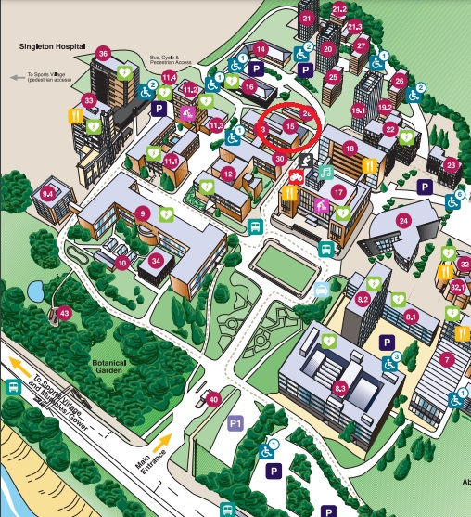
Singleton Campus map with building 15 (Amy Dillwyn building, Swansea University Transcription Centre) circled in red.
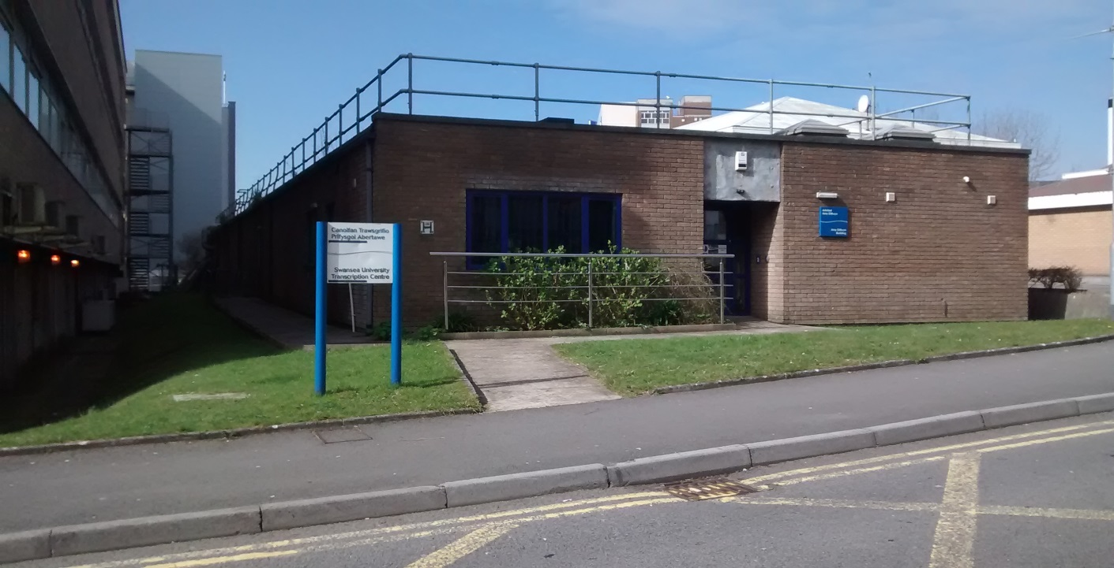
Swansea University Transcription Centre – outside view.
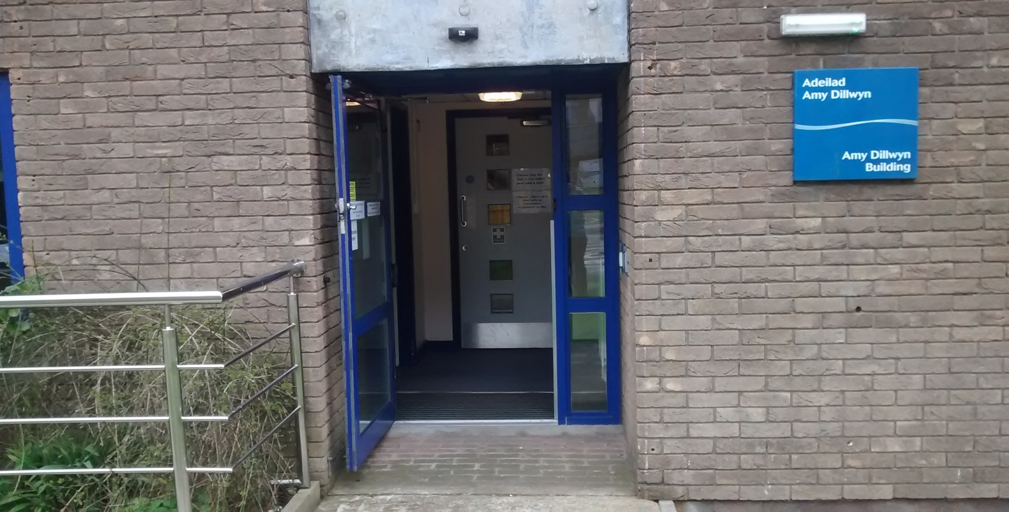
Swansea University Transcription Centre – automatic, sensor operated front door.

The reception area is located at the left.
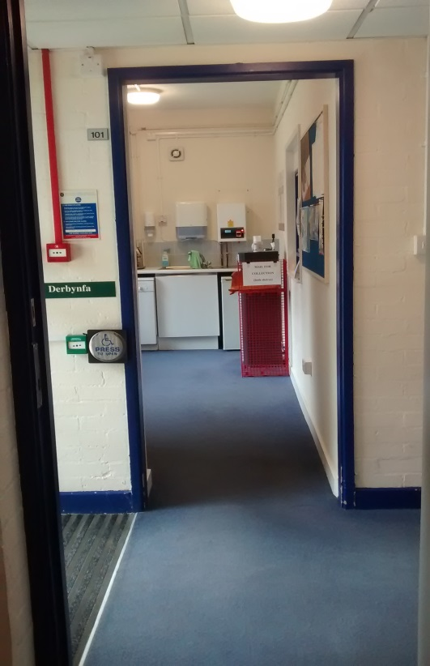
Swansea University Transcription Centre – doorway to reception area
There is a counter with a window, a bell on the right hand side of the counter and a hearing loop system on the counter. The bell can be used to alert members of staff.
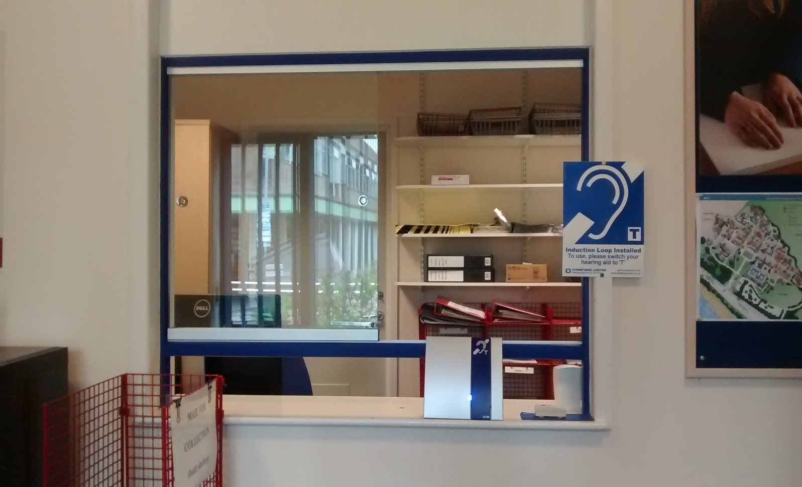
Swansea University Transcription Centre Reception Window/front desk.

Toilet facilities
There are toilets located to the right side of the entrance. Both the ladies toilet and the wheelchair friendly larger toilet have fans which will automatically switch on when the light is operated (switched on). They also have hand driers which can be noisy.
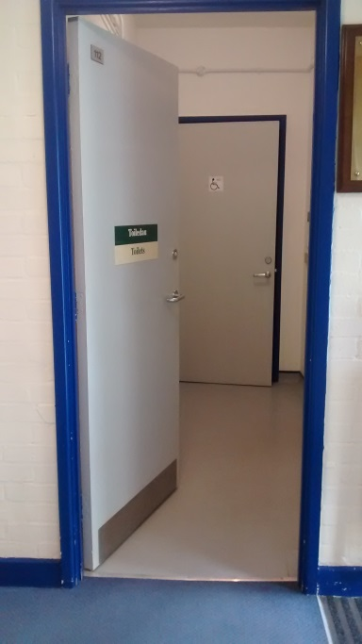
SUTC toilet entrance.
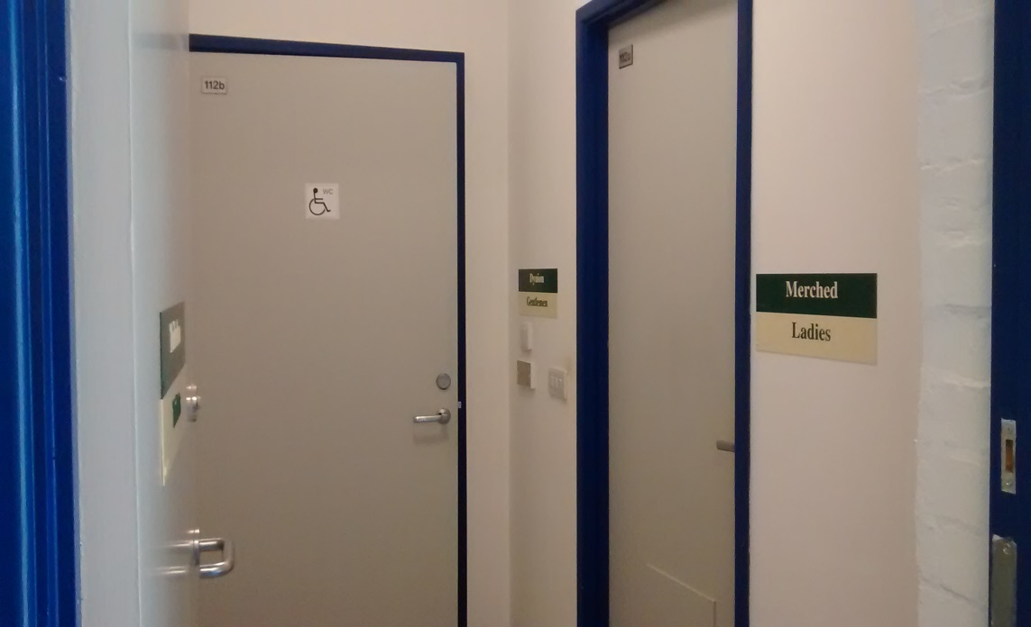
Swansea University Transcription Centre ladies and wheelchair friendly toilets.
The whole building is fitted with contrast features (i.e. darker doorways and window frames) and located entirely on ground floor level. We have overhead lights which can be bright.

Meeting room
A door which is located straight ahead of the entrance area will lead to an inner corridor. The second door to the left will lead into a meeting room with a table and 6 chairs. The room can be made private and has 1 window with natural light.
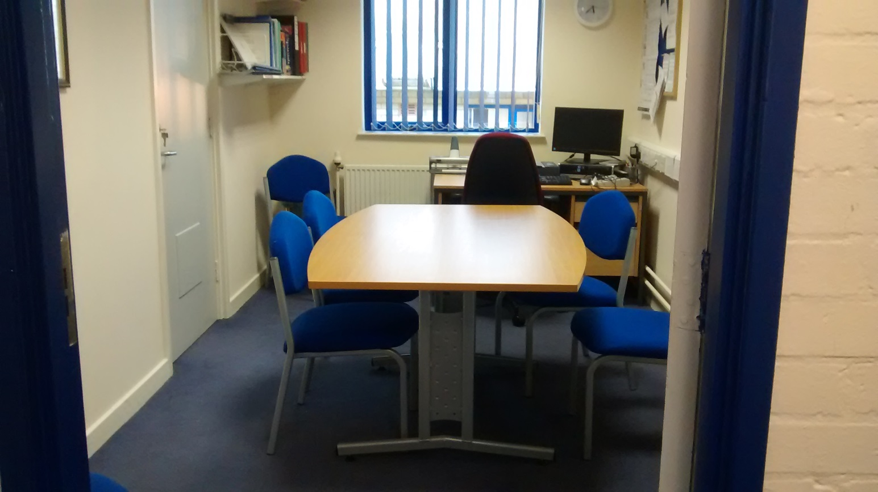
Swansea University Transcription Centre Meeting Room.

General office
The general office is located to the right of the corridor (opposite the meeting room) and contains 4 desks. If members of staff are scanning, there can be some noise disruption. The SUTC also owns an embosser (braille printer) which is located at the very end of the building. It can make a very loud sound when it is used but members of staff try to minimise noise disruption by keeping doors closed.

Fire Alarm Testing
There is a fire alarm test occasionally. This results in a brief but very loud warning sound.

Exiting the building
To open our automated door just push the metal button located to the right.
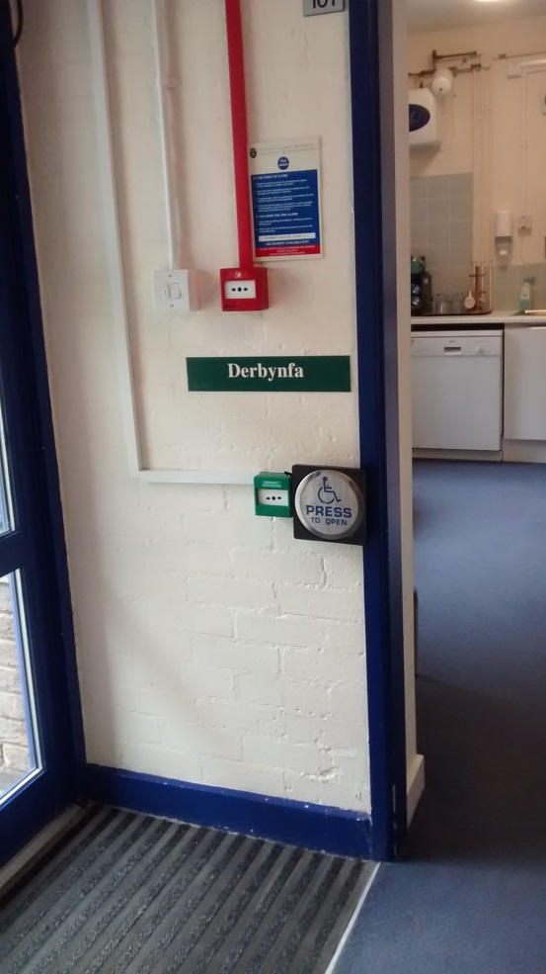

Staff
The SUTC currently employs 2 full-time and 2 part-time members of staff.
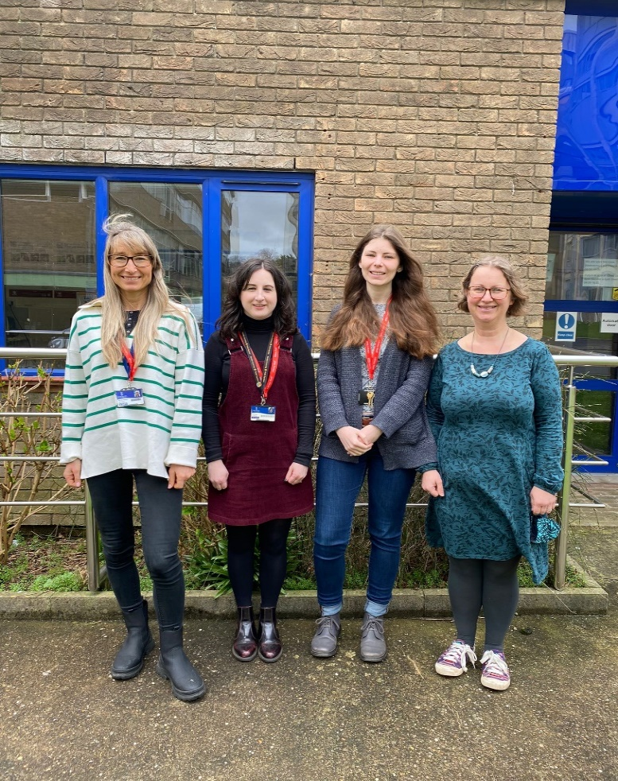
Swansea University Transcription Centre staff (from left to right): Martina Webber (Manager), Naomi Steele, Sofie O’Shea, Angharad Brown (Transcription Co-ordinators).

Mae’r ddogfen hon hefyd ar gael yn y Gymraeg. Diwygiwyd Mai 2022.
This document is also available in Welsh. Revised May 2022.

